 |  |  | R |  | H
 |  |  |  |  |  | A
 | E
 | W |  | AT |  |  |  | W
 |  |  |  |  | I
O |  | S |  |  |  | L
O |  |  |  |  |  | I
O | E | R |  |  |  |  |  | K
P | E
P | E |  |  |  |  | T
P | VSAVES
 |  |  |  |  |  |  | Y |  |  | S
R | LIVES |  |  |  |  |  |  |  | M | S
E |  |  |  |  |  |  |  | E | M
S |  |  |  |  |  |  |  | E
 | C |  |  |  |  |  | T
 | U |  | E |  |  |  | T
 |  |  | E |  |  | S
 |  |  | E | S
 |  |  |  |  |  | Y

POWER HAWK ®
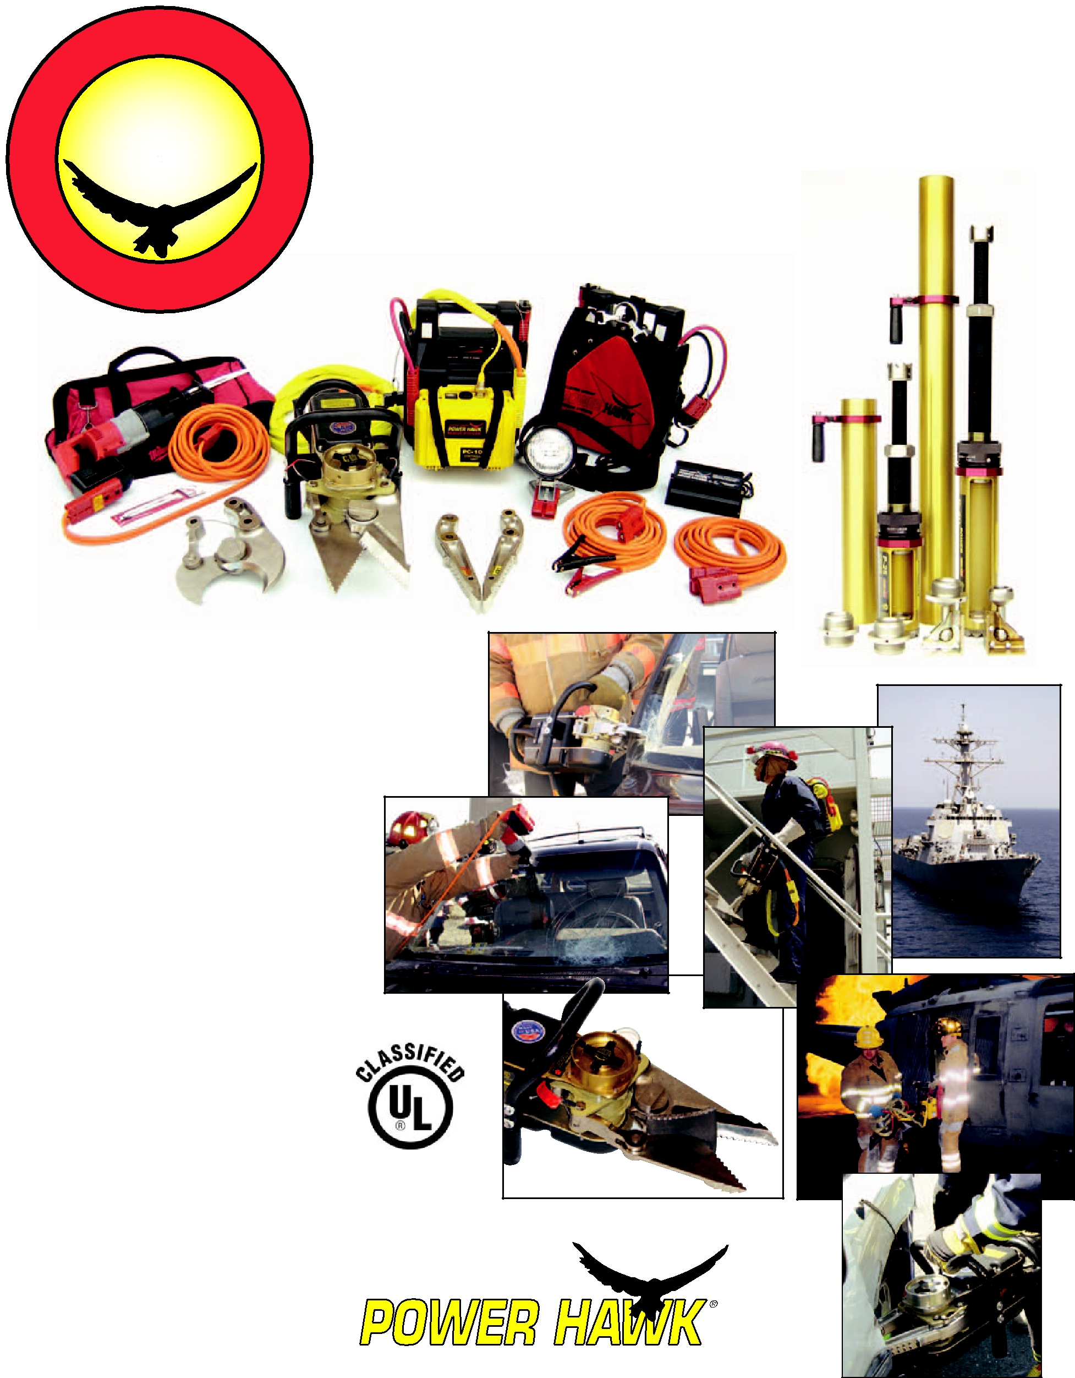
RESCUE SYSTEMS
On The Job
Around The World

This All-Electric (no hydraulics) “jaws” type rescue tool utilizes Curtiss-Wright aerospace gear technology developed for demanding military fighter-jet flight control applications. By eliminating hydraulics completely and utilizing 12 Volts DC power, the VERSATILITY of the POWER HAWK makes it the perfect choice for:

- Vehicle extrication

- Damage Control

- Aircraft rescues

- Rapid-Intervention Teams

- Collapse rescues

- Remote rescues

- Indoor and confined space operations

- Forcible entry

- Special operations

Features:

- NO Hydraulics

- Lightweight & Portable

- Rapid Response/No Setup

- Runs in O₂ Depleted Atmosphere

- Quiet Operation

- Long-lasting Battery

- Low Maintenance

- Interchangeable Spreaders and Cutters
- Compact/Saves Compartment Space

- 12 Volts DC Power/Back-up readily available
- Simultaneously run accessories such as the Milwaukee Sawzall®,RamFan blower, lights, winches, and more.

Rated to

Cut 3/8”

Steel Plate

CERTIFIED

Compliant to
NFPA 1936*

TECHNOLOGIES, INC.

* P-16 Rescue Tool w/S-1601, C-1601, CS-1602, P-25 & P-40 Rams, PWR-3X12 Power Pack www.powerhawk.com · 800-PWR-HAWK

POWER HAWK® P-16 RESCUE SYSTEM SPECIFICATIONS: www.powerhawk.com

NOTE: COLOR SCHEMES OF SOME ITEMS MAY VARY

Patented
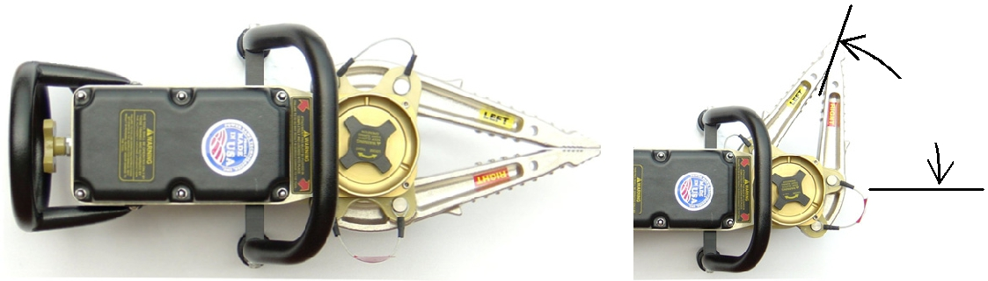
70º Pivot

P-16 Rescue Tool

Powerhead Output Torque 72,000 in-lbs (8135 N-m)
Input / Output Ratio 5958:1
Powerhead Articulation Angle 70°

Attachment Pins: High-strength steel, ball-detent

Motor Inrush Current 220 Amps
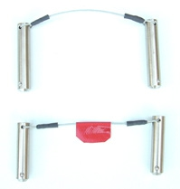
Motor Current @ No Load 23 Amps

Motor Current @ Max. Load 155 Amps

Pigtail Cable Length 12” (305 mm)

With No Attachments
Weight 32 lbs (14.5 kg)
Envelope (LxWxH) 17” x 10” x 12” (432 x 254 x 305 mm³)

With S-1601 Spreaders Attached
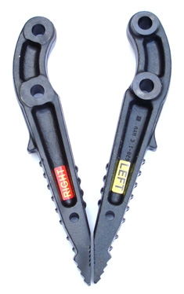
Spreading Force (1” from tip) 8,000 to 11,000 lbs
(35.6 – 48.9 kN)
Spreading Force (At back of arm) 17,530 to 45,240 lbs
(78.0 – 201.2 kN)
Weight 41 lbs (18.6 kg)
Envelope (LxWxH) 25” x 10” x 12”
(635 x 254 x 305 mm³)

Opening Distance 14” (356 mm)
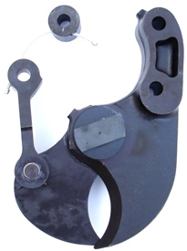
With C-1601 Curved Cutter Attached

Cutting Force (at blade center) 30,000+ lbs (133.4 kN)
Weight 44 lbs (19.9 kg)
Envelope (LxWxH) 24” x 10” x 12”
(610 x 254 x 305 mm³)
Opening Distance 5” (127 mm)

With CS-1602 Straight Cutter Attached
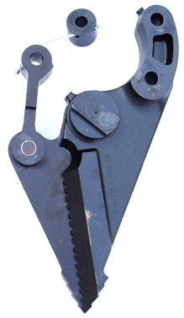
Cutting Force (at notch) 45,000+ lbs (200 kN)
Cutting Force (at blade center) 21,000+ lbs (93.4 kN)
Spreading Force 10,000 to 18,000 lbs
(44.5 – 80.1 kN)
Weight 47.5 lbs (21.5 kg)
Envelope (LxWxH) 27” x 10” x 12”
(686 x 254 x 305 mm³)

Opening Distance 10” (254 mm)

PC-100 Controller Unit

Power Input 12 Volts DC
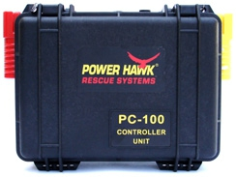
Case Sealed
Weight 5.6 lbs (2.5 kg)
Envelope (LxWxH) 11” x 4.5” x 7.5”

(279 x 114 x 190 mm³)
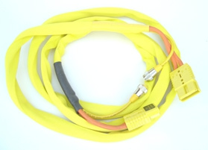
CA-4M Power Cable Assembly

POWER PUSHER® Rams & Extensions
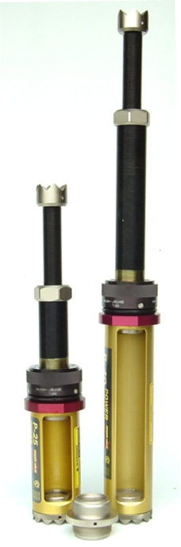
P-40 Power Pusher Ram

Fully Extended Length: | 41 in. | (104.1 cm)
Fully Retracted length: | 23 in. | (58.4 cm)
Stroke Length: | 12 in. | (30.5 cm)
Adjustment Length: | 6 in. | (15.2 cm)
Housing Slot Width: | 2.25 in | (5.7 cm)
Weight: | 36 lbs. | (16.3 kg)

P-25 Power Pusher Ram

Fully Extended Length: | 27 in. | (68.6 cm)
Fully Retracted length: | 16 in. | (40.6 cm)
Stroke Length: | 5 in. | (12.7 cm)
Adjustment Length: | 6 in. | (15.2 cm)
Housing Slot Width: | 2.25 in | (5.7 cm)
Weight: | 27 lbs. | (12.2 kg)
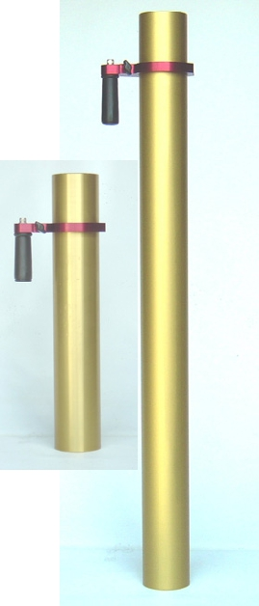
E-24 Ram Extension

Length 24 in. (61.0 cm)

Weight with handle 15 lbs (6.8 kg)

E-48 Ram Extension

Length 48 in. (121.9 cm)
Weight with handle 30 lbs (13.6 kg)

2C0516-1 Ram Coupling
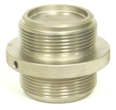
Connects Power Pushers and
Extensions. Weight: 6 lbs (2.7 kg)

2C0551-1 Swivel Base Set

Attach to Rams/Extensions for angled operations.
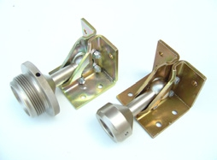
Weight: 13 lbs (5.9 kg)
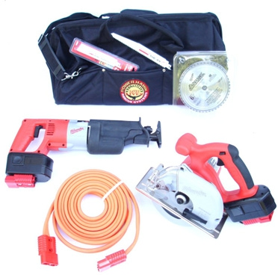
Saw Extrication Kits

SZA-1015 Kit includes Milwaukee Cordless Sawzall, Power Adapter, 16 Ft. Power Cable, 5 Torch Blades, 1 Ax Blade, Contractors Bag. Weight: 18 lbs. (8.2 kg)
SZK-2000 Kit adds Milwaukee 6.5” Circular Saw, Metal Cutting Blade and Power Adapter. Weight: 25 lbs (11.3 kg)
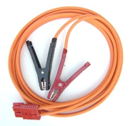
JC4-16 Jumper Cables

16 Ft. 4 Ga. Red connector one end, Heavy-duty clamps other end.

EC4-16 Extension Cable
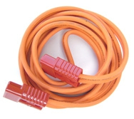
16 Ft. 4 Ga. Red connector both ends
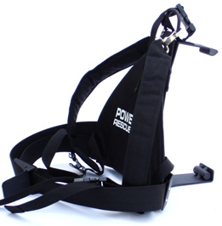
BKPK-100 Back Pack

Back pack for Power Pack. Weight: 5 lbs. (2.3 kg)
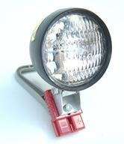

Cable Length 13 ft (4 m)
Weight 6.8 lbs (3.1 kg)

PWR-3X12 Power Pack

Battery Type | 12 | V, Valve-Reg., Sealed Lead-Acid
Battery Capacity | 33 | Ampere Hour
Case | Fully Vented
Charge Indicator | 5 LEDs with test button
Power Connectors | 2 high amp, 1 low amp
Weight: | 33 lbs (15.0 kg)
Envelope (LxWxH) | 12” x 6.5” x 15.5”
 | (305 x 178 x 368 mm³)
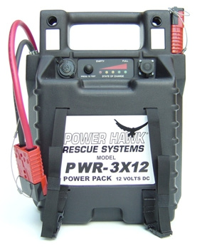
LB-1204 Flood Light

50 Watts, 3.9 Amps, 4” Dia. Halogen bulb. On/Off switch.

BC-U1 Battery Charger

Input Voltage & Freq. 90-230 V AC, 50-60 Hz
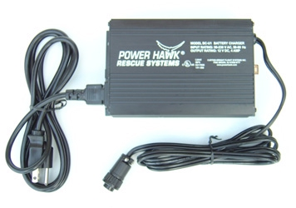
Max. Output Current 4 A ± 5%

Max. Output Voltage 14.8 ± .20 V DC

Weight 2.4 lbs (1.1 kg)
Envelope (LxWxH) 6.8” x 4.2” x 2”
(172 x 107 x 51 mm³)

POWER HAWK Technologies, Inc. 300 Forge Way, Suite 2, Rockaway, NJ 07866 Tel: 973-627-4646 Fax: 973-627-4622 Rev B 10/2008

